**LED'S ON PI**

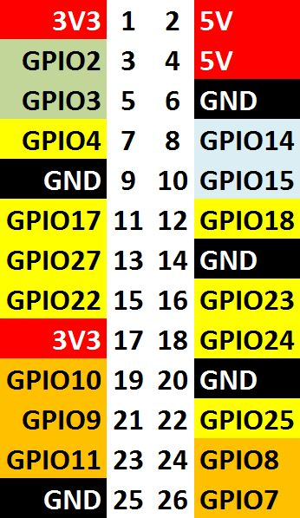 to GPIO --------|>------^^^^^^-------- to GND (set will turn on) 390 ohm or so

Install from NPM 'fastgpio'

to use:

if(os.type() != 'Windows_NT') // this is only for the pi {

var led = require('fastgpio');

led.prepareGPIO(4);

led.set(4); // this is the GPIO number

}

};

exports.ledOff = function(){

if(os.type() != 'Windows_NT') // this is only for the pi {

var led = require('fastgpio');

led.prepareGPIO(4);

led.unset(4);

}

};